DATA ANALYSIS🡪"Data analysis empowers us to understand the past (hindsight), predict the future (foresight), and make informed decisions (insights) in the present.

**Easy Comparison:** **Bar charts** excel at visually comparing the values of different categories. The length of each bar directly represents the magnitude of the data

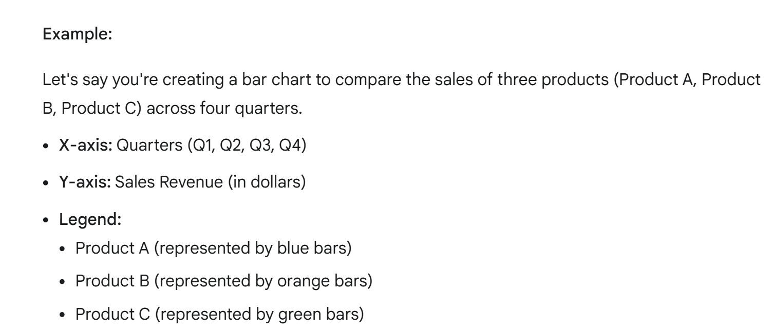

FORMAT🡪 EDIT INTERACTIONS🡪 TO ESTABLISH RELATIONSHIP BETWEEN VISUALS

When do we use KPI🡪 In my role, I developed a KPI dashboard to monitor our progress towards a critical monthly revenue target of 1.7 million

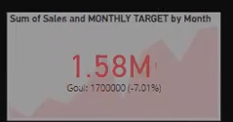 DECEMBER SALES ARE 7 PERCENT LESS THAN THE MONTHLY TARGET (AREA CHART SHOWS SALES PER MONTH)

Gauge we use🡪 when we want to know how beyond we are from our profit

**(clear all slicers)button 🡪Insert**🡪**buttons**🡪**clear all slicers**

**For specific category button**🡪 first select whatever u want then go🡪 View🡪Bookmark🡪rename(customize)🡪 insert🡪bookmark🡪click that visual 🡪format🡪 action🡪 customize

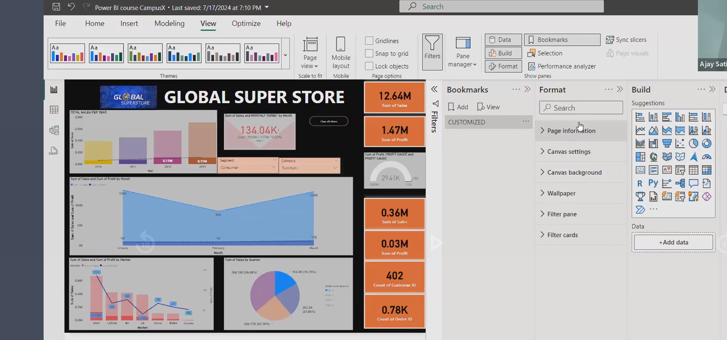

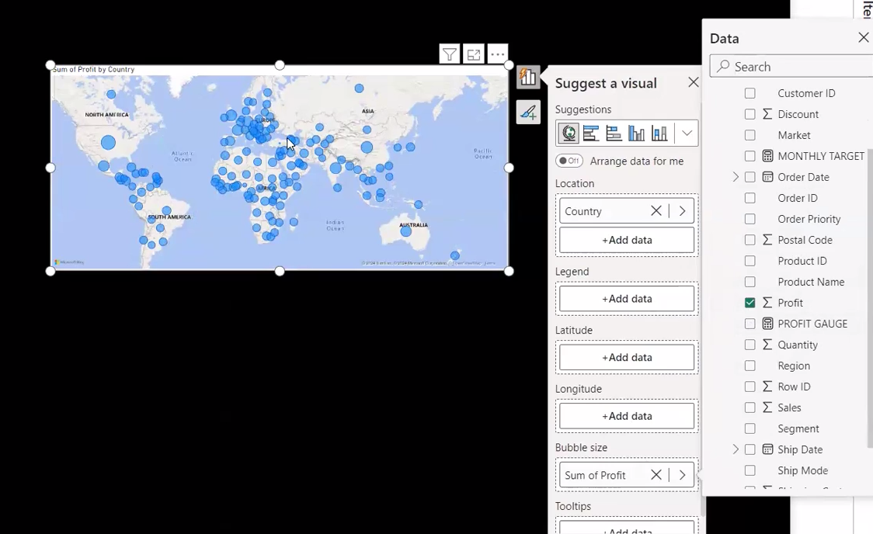

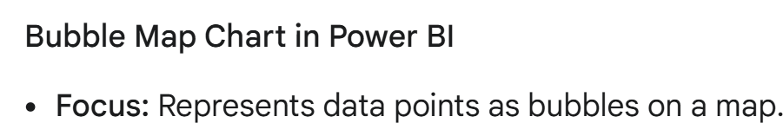



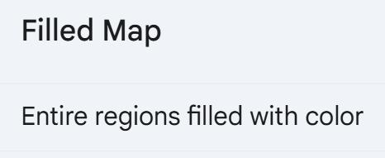

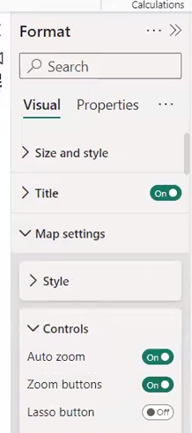

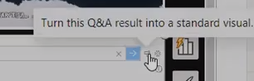

**To give responsibility and roles we have a feature in power bi service called MANAGE ACCESS.**

**ADMIN**

**MEMBER**

**CONTRIBUTOR**

**VIEWER**

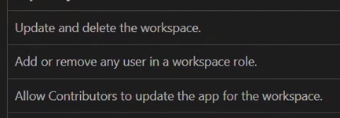

**Only admin can do it**

**\*\* we define rules and regulations in power bi desktop (dax,m,power query)**

**\*\* we defines roles and responsibility in power bi service**

**Power bi desktop🡪(RLS)MODelling🡪security🡪 manage roles 🡪publish**

**Power bi service🡪 semantic model🡪 … 🡪 security🡪 enter email address**

**RLS ONLY APPLIES TO VIEWER**

**\*\*DASHBOARD IS AN HYPERLINK TO DIFFERENT DIFFERENT REPORT PAGES**

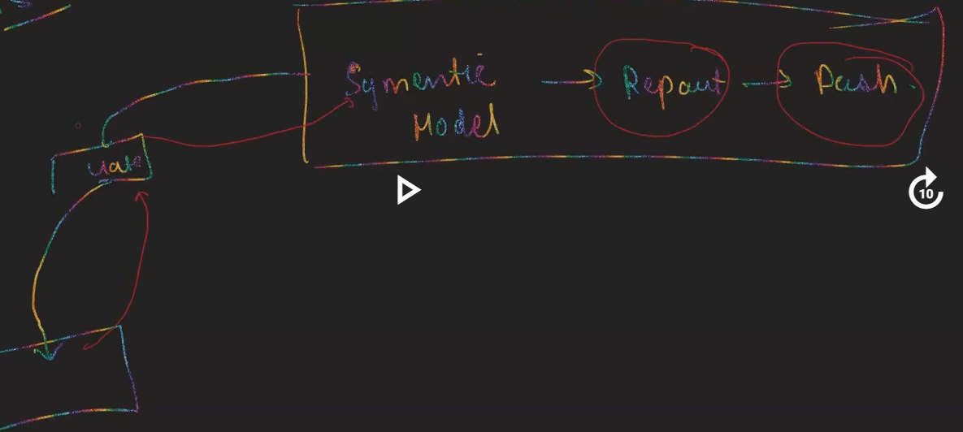

**AT THE SCHEDULE TIME POWER BI WILL TRIGGERED THE GATEWAY AND THIS GATEWAY GETS THE DATA IN A CONTROLLED MANNER FROM THE DATA SOURCE**

**DATA SOURCE🡪 GATEWAY🡪SEMANTIC MODEL🡪REPORT🡪 DASHBOARD**

**GATEWAY IS THE CONNECTION BETWEEN POWER BI SERVICE AND THE DATA SOURCE**

**• Enable Sync Slicers: Go to View > Sync Slicers. This activates the Sync Slicers pane.**

**• Select Pages: In the Sync Slicers pane, select the pages where you want the slicer's selections to be synchronized.Dimension Tables:**

* **Primarily contain descriptive attributes. These are often textual, categorical, or temporal in nature.** 
  + **Examples: Product names, customer names, country names, dates, categories.**

* **Can also include some numerical data. For example, a product dimension might include a product ID (numerical).**

**Fact Tables:**

* **Primarily contain quantitative measurements. These are typically numerical values that represent business metrics.** 
  + **Examples: Sales amount, order quantity, profit margin, temperature, stock price**

**Normalization in database design is the process of organizing data within tables in a database to minimize redundancy and improve data integrity**

**• Pie Chart: A pie chart is a complete circle divided into slices, each representing a category's percentage of the whole.**

**• Donut Chart: A donut chart is similar to a pie chart, but it has a hole in the center**

**Center Hole: The most obvious difference is the hole in the center of a donut chart. This can be used to display additional information, such as a total value or a summary statistic**

**• Pie Chart: Use a pie chart when you have a relatively small number of categories (typically fewer than 6) and want to emphasize the proportion of each category to the whole.**

**• Donut Chart: Use a donut chart when you want to display additional information in the center or when you have a larger number of categories.**

**QUERIES =TABLE IN POWERBI**

**GENDER /NAME 🡪 WE CAN MERGE THESE COLUMNS THIS WILL OPTIMIZE THE SPACE**

**If I don’t want to load the table in my power bi desktop then there is one option when u click on the table (UNABLE LOAD)🡪 IT WILL NOT LOAD IN YOUR POWER BI DESKTOP AND IT WILL SAVE THE SPACE**

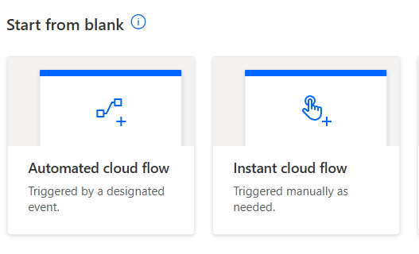

**Q **

**Ans** 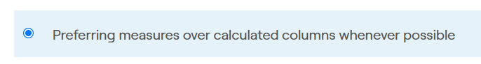



**Ans** 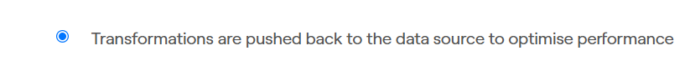

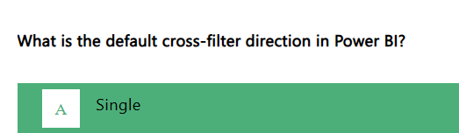

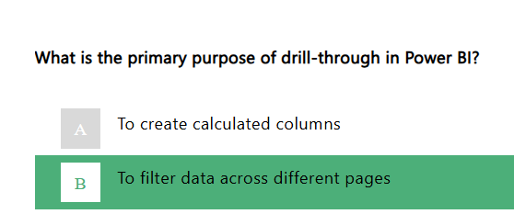

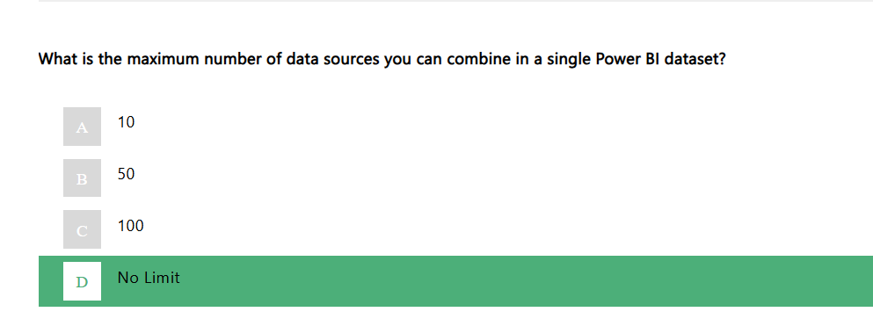

**NULL HYPOTHESIS SAID THERE IS NO RELATIONSHIP**

**IF F VALUE IS LESS THAN 0.05 THEN WE REJECT NULL HYPOTHESIS,AND WE PROVE THERE IS A RELATIIONSHIP**

**MYSql 🡪 didn’t have a option for direct query BYDEFAULT(IMPORT)🡪 ON LOCAL SERVER**

**SQL SEVER 🡪 HAVE TO TWO OPTION**

* **Import**
* **Direct query**

**POWER BI DESKTOP 🡪 IS A CREATION TOOL**

**POWER BI SERVICE 🡪 IS A PUBLISING TOOL,we publish reports here,security setup,manage access,it requires organisational id and not yours personal id**

**QUERY FOLDING🡪**

Query folding is a powerful technique in Power BI that significantly enhances data processing efficiency and performance. It allows Power Query to push down data transformations and filtering operations to the data source itself, rather than performing them within Power BI. This results in several key benefits:

* Reduced Data Transfer: By processing data at the source, only the necessary data is transferred to Power BI, minimizing network traffic and storage requirements.
* Faster Processing: Data sources often have optimized engines for handling large datasets, leading to quicker query execution compared to processing within Power BI.
* Improved Scalability: Query folding enables Power BI to handle larger datasets more efficiently, as the processing load is distributed between Power BI and the data source.

**Percentile**

* **Definition: A percentile indicates the percentage of values in a dataset that fall below a specific value.**

**In dax 🡪 &&   
in M 🡪 and use then instead of (,)**

**Power BI Reports🡪 In-depth data analysis and exploration,DesignMulti-page, complex layouts, detailed visualizations**

**Power Bi Dashboards🡪 High-level overview and monitoring,Single-page, concise layout, key performance indicators (KPIs)**

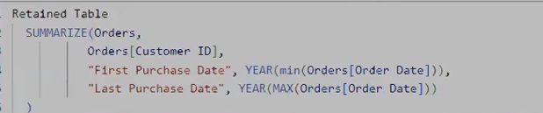

**Q1 IS IT POSSIBLE TO MAKER MULTIPLE FUNCTIONAL RELATIONSHIP IN POWER BI?**

**ANS Yes it is possible to make multiple relationship, but only one relationship is active once at a time.**

**Q2 While in power query,how effective is DAX works?**

**Ans M language works in power query and dax not works in power query .**

**For Simple Transformation we use the M language that will increase the performance**

**Q3 what are different types of filters in Power Bi and what their order of capabilities?**

**Ans 1 Filter on this page-🡪 2**

**2 Filter on all pages -> 1**

**3 Filter on this visual🡪3**



**Q4 What is the difference between matrix and visual? (GRID VISUALS)**

**Ans In Matrix we have three options🡪 Columns,Rows and Values(Pivot Form)**

**In table we have one option i.e. Columns (Unpivot Form)**

**Q5 Can u explain data lineage concept in Power bi?**

**Ans How our next step is connected to previous steps that is called as DATA LINEAGE**

**Explanation:**

1. **Data Sources: This is the starting point. Data can originate from various sources like databases, files, APIs, etc.**
2. **Data Ingestion: Data is extracted from the sources and brought into the Power BI environment.**
3. **Data Transformation: Data is cleaned, shaped, and prepared for analysis. This may involve steps like data cleaning, data type conversion, and data aggregation.**
4. **Data Modeling: Data is organized and structured into a logical model within Power BI. This often involves creating relationships between tables and defining measures.**
5. **Data Storage (Datasets): The transformed and modeled data is stored in Power BI datasets.**
6. **Data Visualization (Reports): Finally, the data is visualized in reports using charts, graphs, and other visual elements.**

**Q6 Difference between search and find?**

**Ans SEARCH 🡪 WILD CARD CHARACTERS USED(*)**

**FIND🡪 WE CANT USE WILD CARD CHARACTERS(*)**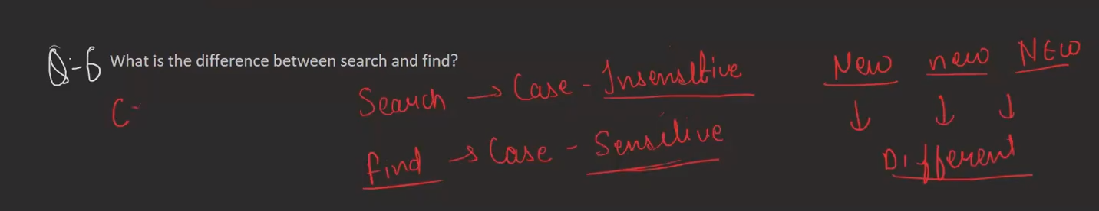

**Q7🡪**

**Ans**

**Q8** 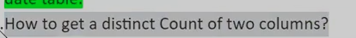

**Ans**

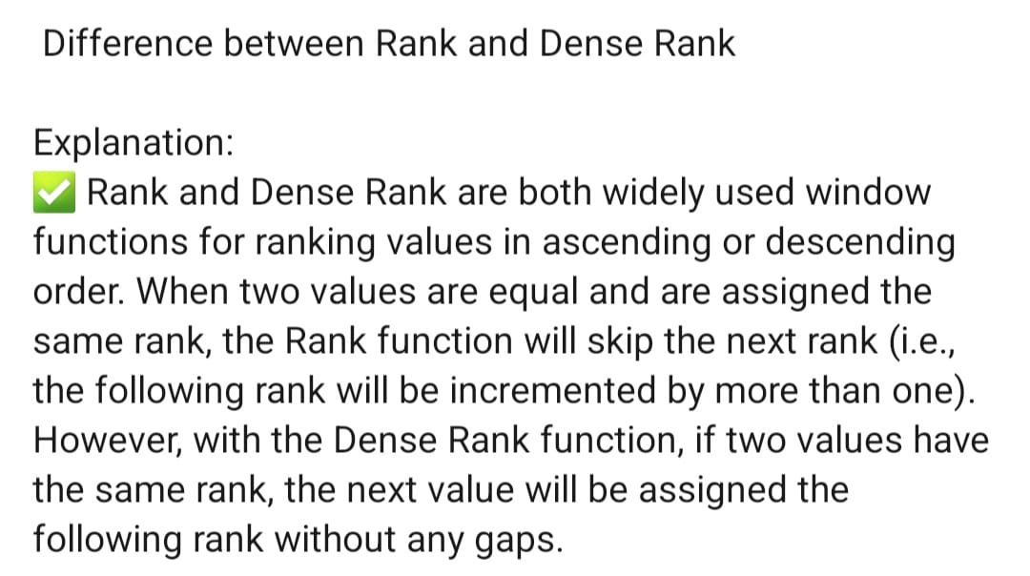

**Q** 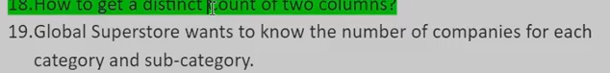

**ANS **



**ANS**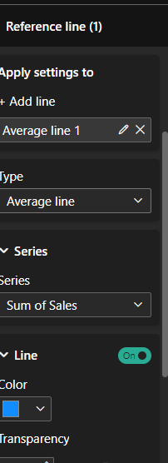

**Q **

**ANS yes**

**Q** 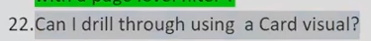

**Ans YES**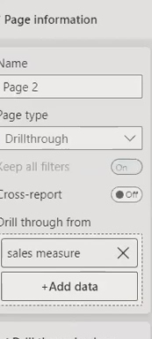

**Q CN WE DRILL THROUGH ALL THE VISUALS?**

**ANS YES**

**Q **

**Ans** 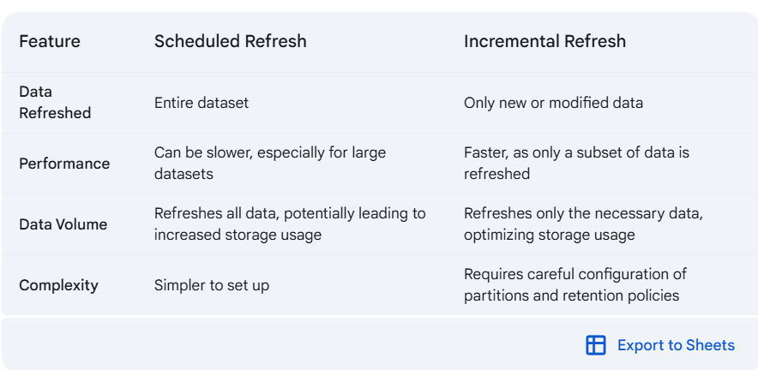

**q**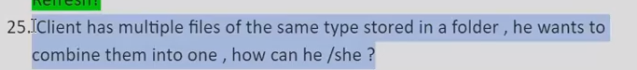

**ans TRANSFORM DATA 🡪 NEW SOURCE🡪FOLDER🡪PICK LOCATION**

**OR U CAN USE APPEND QUERIES**

**Q** 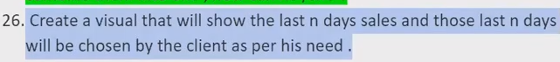

**ans**

**Q9 EXPLAIN THE DIFFERENCE BETWEEN MEASURE AND CALCULATED COLUMNS?**

**ANS Calculated Columns:🡪**

* **Row-level Calculations: Calculated columns perform calculations for each row in a table.**
* **Storage: The results of these calculations are stored as a new column in the table, consuming additional storage space.**
* **Performance: Can impact performance, especially with large datasets, as calculations are performed for every row during data refresh.**

**MESAURES 🡪 Measure aggregate dynamically based on the context of the visuals**

**No Storage: Measures are stored as formulas and do not consume additional storage space.**

**Q10 HOW DO U HANDLE WITH MISSING VALUES?**

**ANS WE CAN GO FOR Imputation:**

* **Mean/Median/Mode Imputation: Replace missing values with the mean, median, or mode of the column. Simple but can introduce bias.**
* **K-Nearest Neighbors (KNN): Find the k-nearest neighbors with complete data and use their average to impute the missing value.**

**AND THE OTHER THINGS WE DO IS TO GO BACK TO THE SOURCE AND ASK THEM TO PROVIDE THE MISSING VALUES IF THEY CAN**

**Q11 WHAT DO U MEAN BY DAX**

**ANS DAX stands for data analysis expression and it is the coding language of power bi and it is used to make calculated columns and measures**

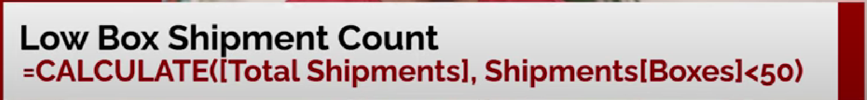

**Q12 how do u optimize the performance of powerbi reports?**

**Ans**

**Q13 WHAT DO U MEAN BY 1,* AND -> IN THE DATA MODEL DIAGRAM?**

**ANS 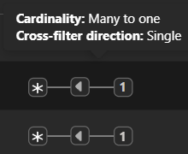 > CROSS FILTER DIRECTION**

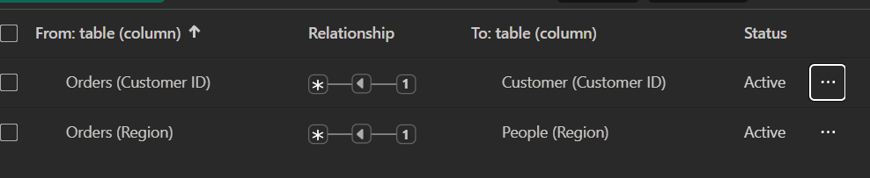

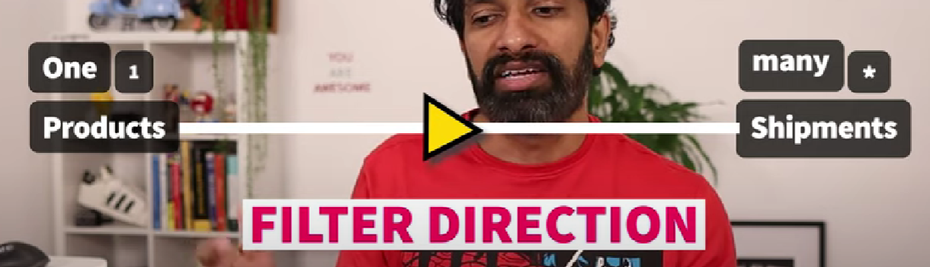

**Q what do u mean by slowly changing dimensions(SCD)?**

**ANS Dimensions that are changing over time**

**Source🡪 power query(data transformation)(M language) 🡪 power bi desktop(dax used here)🡪 power bi services**

**SWITCH(Expressions(day),”input”,”output”,”input”,”output”,”output”)**

**Table in power BI🡪 if u want to show some information in detail and want to filter particular values on the basis of different different column then use Table**

**Table🡪 1 input i.e. Column**

**Matrix🡪 3 input i.e. Row,Column,Values**

**24 Different Types of Views in Power BI(business Intelligence):**

**1 Report View:** This is the primary view for creating and designing interactive reports.

You can add visualizations, format elements, and create multiple pages**.**

**2 Table View:** Provides a tabular view of your data, like an Excel spreadsheet.

It's helpful for data cleaning, validation, and understanding relationships.

**3 Model View:** how different datasets are connected to each other

**4 DAX Query View:** Coding language of Power BI

**CSV:** COMMA SEPARATED VALUES🡪 TO STORE RAW DATA (Tabular form)

**XLSX (MICROSOFT EXCEL SPREADSHEET)🡪** TO PRESENT THE DATA (COLOR STAY)

**IOT – Without human intervention data transferred from one device to another**

**FMCG-** Fast Moving Consumer Goods **e.g. Soaps, shampoo**

**API:(Application Programming Interface):** Link to fetch data from Server

**e.g. Weather API, Google Maps API**

**Q HOW DATA COLLECTED?**

**1.**Often, **web scraping** is used to extract data from websites, and then ETL processes are used to transform (**HANDLING WITH MISSING VALUES, REMOVE DUPLICATES OR CONVERTING DATA TYPES)** and load that data into a **data warehouse or data lake** for further analysis

**2.E(EXTRACT):** Takes data from different sources and put them into buffer space and then transform it

**T(TRANSFORM)-** Convert as per the need

**L(LOAD)**

**3. Manual Entry**

**4. IOT (Internet of Things)**

**OLAP AND OLTP ARE DATA PROCESSING AND MANAGEMENT CONCEPTS(NEITHER SOFTWARE NOR HARDWARE)**

* **OLAP (Online Analytical Processing):** When you need to analyse historical data to identify trends, patterns, and insights.
* handle complex queries(aggregations,logics,merging,joining)**. Used for business analytics, data analytics tasks**
* **Historical data store + current data feed**
* **Response time is slow**

**EXAMPLE: Power BI IS BUILD ON THE CONCEPT OF OLAP**

**OLTP (Online Transaction Processing): example: Automated Teller Machine (ATM)**

* When you need to handle day to day routines, real-time transactions, such as online purchases or bank transfers.
* **Handle basic queries** (CRUD) Create, Read, Update and Delete
* **It Prioritizes low latency responses**
* **Low-latency responses** refer to the ability of a system to respond quickly to requests or inputs

**Submission sign indicates(E): Numerical column**

**Whenever u want to show particular piece of information,show it by using a card(VISUALS)**

**WHENEVER U WANT TO SEE VARIATION USE THE LINE CHART**

**KPI stands for Key Performance Indicator. It's a quantifiable metric that measures how well a company or organization is achieving its objectives. KPIs are used to track progress, identify areas for improvement, and make data-driven decisions.**

**Graph behind KPI is AREA CHART OF SALES AND MONTH**

**GAUGE- HOW FAR AND HOW NEAR TO PARTICULAR VALUE ,WE USE GAUGE**

**WHEN NO TREND AXIS IS GIVEN ,USE GAUGE**

**gauges are a great choice in many scenarios**

* **Show the health of a single measure.**
* Show progress toward a goal.
* **KPIs** in Power BI compare your current performance to a set goal. We measure it along the axis(month)
* **Example:** "For instance, if we're tracking monthly sales, an area chart can show us how sales have increased or decreased over the past year. We can easily identify peak sales months and periods of decline."
* **GAUGE**: how beyond we are from our target value i.e. use gauge without any given axis

**Why Use Funnel Charts?**

* **Identify Bottlenecks:** Easily spot stages where the process slows down or drops off.

imagine you're selling a product online. You start with a large number of potential customers (leads). As they move through your sales process, some will drop off at each stage:

1. **Website Visitors:** Many people visit your website but don't make a purchase.
2. **Cart Additions:** Some people add items to their cart but don't complete the purchase.
3. **Purchases:** A smaller number of people actually complete a purchase.

A **funnel chart** visually represents this process, showing how the number of potential customers decreases at each stage. It looks like a funnel, wide at the top and narrow at the bottom.

**Funnel chart compares it with previous and top level,gives u a relative percentage**

**Maps setting 🡪 control🡪 lasso setting on**

**Grid Visuals:** displays data in a traditional table format with rows and columns.

Grid visuals are used when we have to show the information in detail

**Double click** on the column and then it will change to its order(ascending to descending or descending to ascending)

**Two visuals are there in it :**

* 1. **Table Visual**
  2. **Matrix Visual**

**Table Visual:**

* **Displays data in a traditional table format with rows and columns.**
* **Perfect for simple, straightforward data presentation.**
* **Can be customized with various formatting options.**

**Matrix Visual:**

* **More versatile than the table visual.**
* **Allows you to organize data hierarchically, similar to a pivot table in Excel.**
* **Great for complex data analysis and drill-down capabilities.**

**Tooltips in Power BI are interactive elements that provide additional information about data points without disturbing the parent visual when you hover over them.**

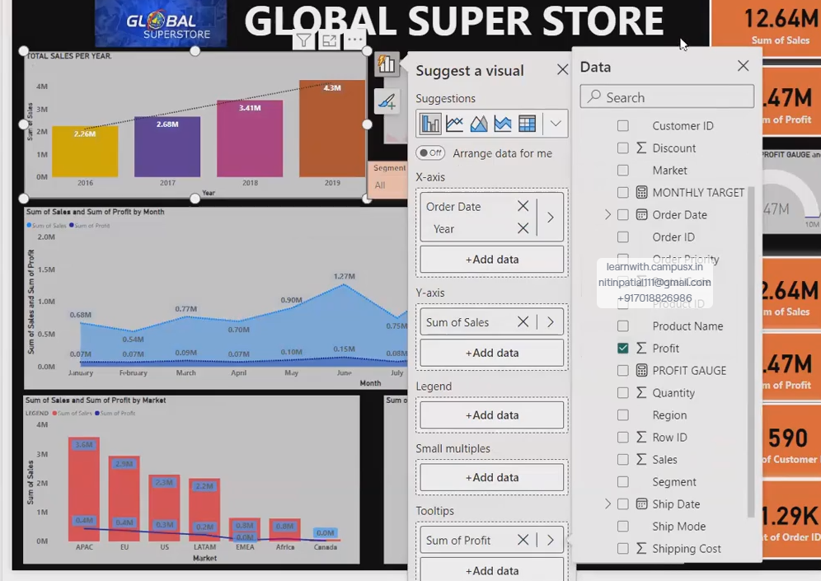

**NOW THIS WHOLE PAGE ACTS AS A TOOLTIP (below):**

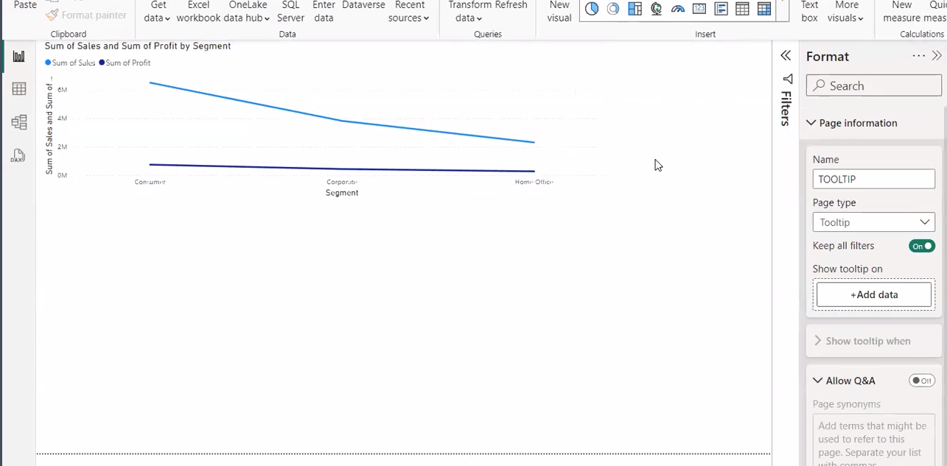

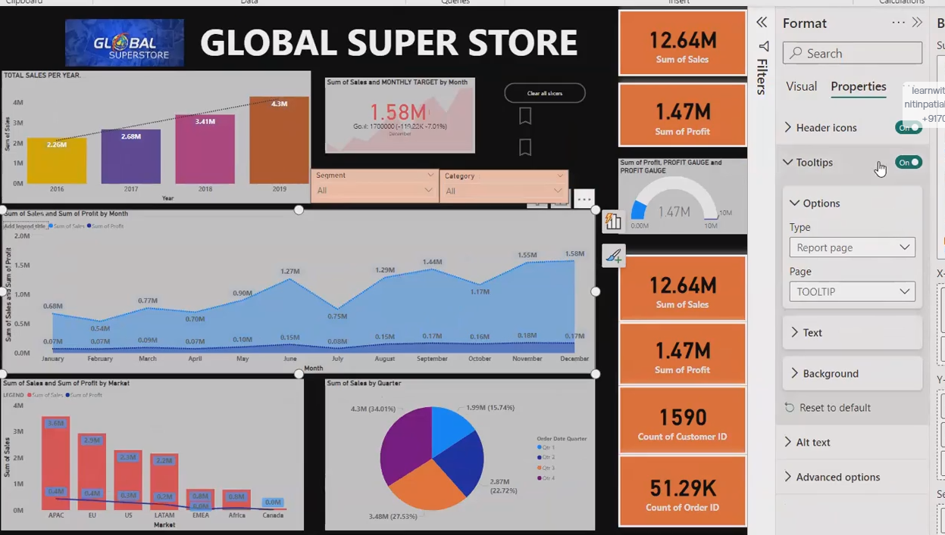

**\*\*filter on parent visual also put filter on tooltip page (filter refine the visuals(slicer))**

**Slicer modify according to the filter**

**View-🡪 Filter**

**Power BI, filters are used to refine and focus the data displayed in your visualizations**

**Three types of filter:**

* 1. **Filter on this page(basic and advance filtering)**
  2. **Filter on all pages(Basic and advance filtering)🡪 static cards also affected**
  3. **Filter on this visuals (basic,advance,top N)**

**Basic filtering 🡪 select or deselect**

**Advance Filtering🡪 Use logics here(AND /OR)**

**Drill through: Copying the selection of one visual from one report page to another report page.Drill through is a filter**

**Q Can single page is your drillthrouigh or tooltip?**

**Ans No**

**Hiearchy🡪 Day🡪Month🡪Quarter🡪Year**

**Drill Down:**

* **Definition: Drill down is the process of moving from a higher level of data to a more detailed level.**
* **Create a Hierarchical Relationship: Establish a hierarchical relationship between your data fields (e.g., Country > Region > City).**

**Drill Up:**

* **Definition: Drill up is the opposite of drill down. It's the process of moving from a lower level of data to a higher level.**

**Difference between filters and Slicers?**

**Ans Slicer is a type of visual ,its always in report view page**

**Select/diselect**

**Can connect/disconnect a visual with slicer using edit interaction**

**Filter: Functionalities, not present in working area, separate filter pane**

**Advance filtering(logic statements)**

**Apply to all(no flexibility of edit interactions)**

**Performance and applicatibility :**

**Filter applies first as compare to slicer**

* + - * **\*\* slicer filter ke hisab se modify ho jayega**

**DATA MODELLING : If u want multiple tables to communicate with each other u create a relationship between them.This is called Data Modelling**

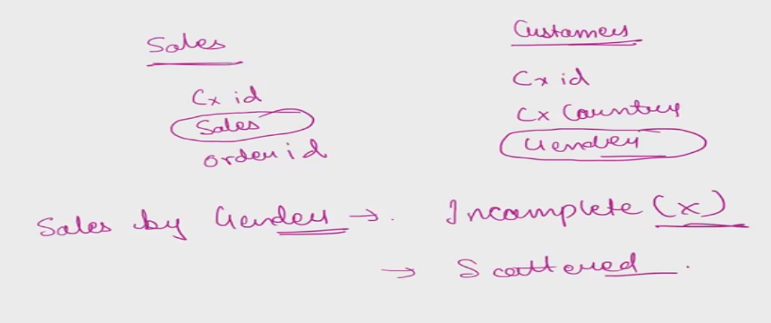

**Here the information is not incomplete but it is scattered**

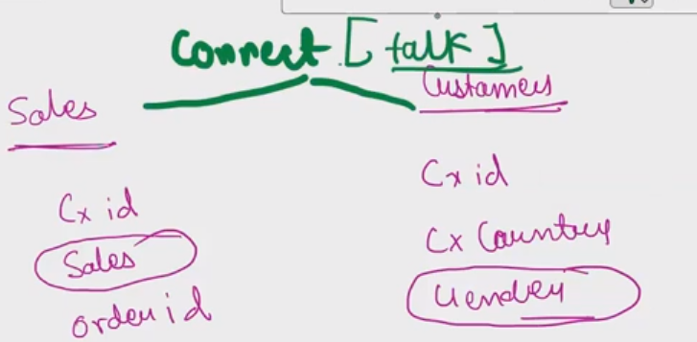

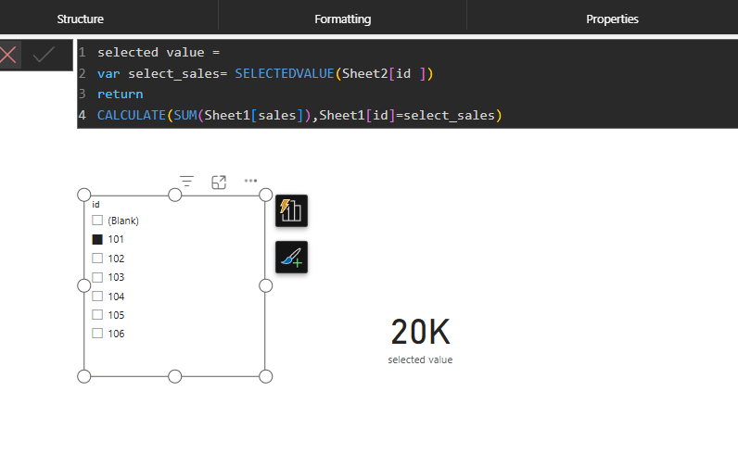

**Connection-🡪 Common features (data modelling)**

**Cardinality means how rows are connected between tables**

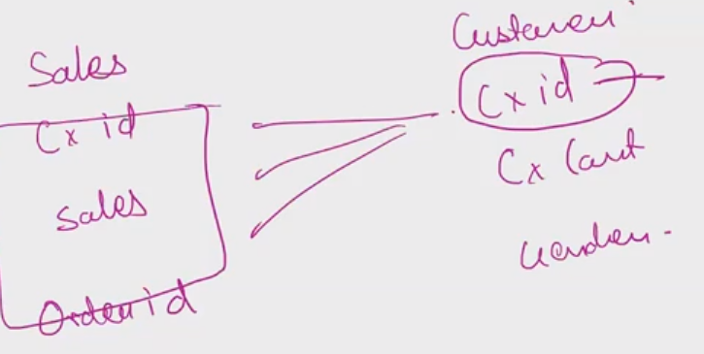

**Four types:**

* 1. **One to One : **
* • One person can only have one passport.
* • One passport can only belong to one person.  
  Adhar card number🡪 Pan card number

**Unique Pairing: Each item in one box is paired with exactly one item in the other box.**

* + 1. **One to many: 1 student can choose multiple subjects**
* • A customer can place many orders.
* • An author can write many books.
* • A department can have many employees.
  1. **Many to one: multiple instances of one entity can be associated with a single instance of another entity.**

**Father can have multiple child**

* • Many employees can work for one company.
* • Many books can be written by one author.
* • Many patients can be treated by one doctor.
  + 1. **Many to Many: multiple instances of one entity can be associated with multiple instances of another entity.**
* • Many customers can buy many products, and many products can be bought by many customers.
* • **Courses and Students:** Many students can take many courses, and many courses can have many students.

**It is possible to make multiple relationship between tables but there is only one relationship active one at a time**

**DAX, or Data Analysis Expressions, is a formula language used in Power BI to create custom calculations and insights from your data. It's like Excel formulas,**

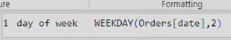

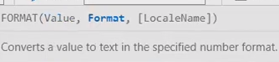

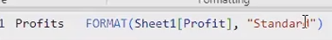 **#format,table ka name,column name,standard**

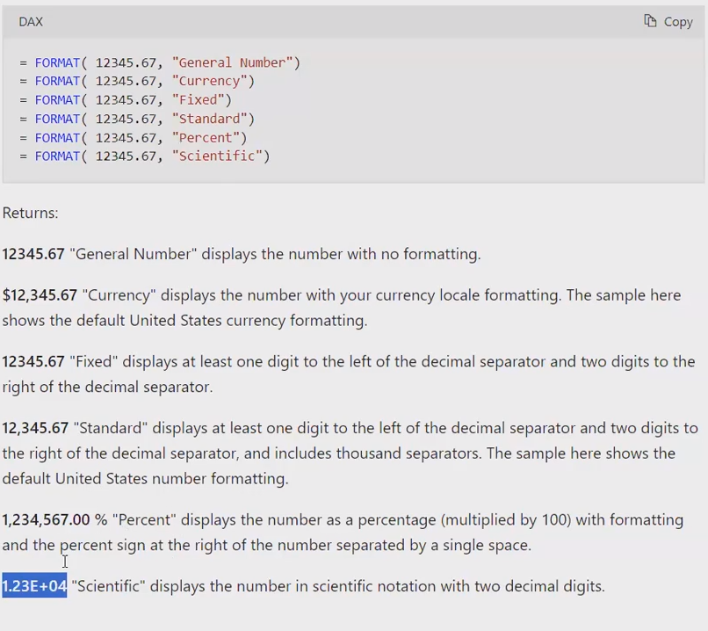

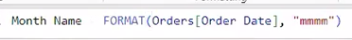

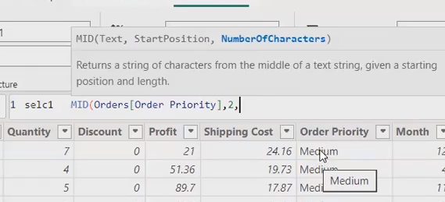

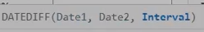



**BY default power bi**

**Sunday=1**

**Saturday=7**

**FORMAT DAX – Use to convert the values in particular format**

**Format (Numeric, text and date) convert into desired format**

**SWITCH(**

**<expression>,**

**<value1>, <result1>,**

**<value2>, <result2>,**

**...,**

**<default_result>**

**)**

**When to Use SWITCH in Power BI🡪**

* **Multiple Conditions: When you need to evaluate an expression against a series of values and return different results based on those matches.**
* **Replacing Nested IFs: To simplify and improve readability of formulas with multiple nested IF statements.**

**Key Points:**

* **The SWITCH function evaluates the expression against the values in order.**
* **As soon as a match is found, the corresponding result is returned, and the remaining values are not evaluated.**
* **The default result is optional. If no match is found and no default is provided, the result will be blank.**

**By using SWITCH, you can create more concise and maintainable DAX formulas, especially when dealing with multiple conditions.**

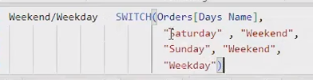

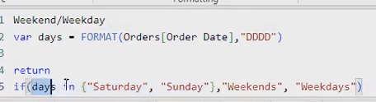

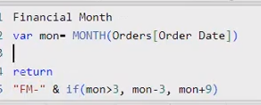

**COST PRICE🡪**

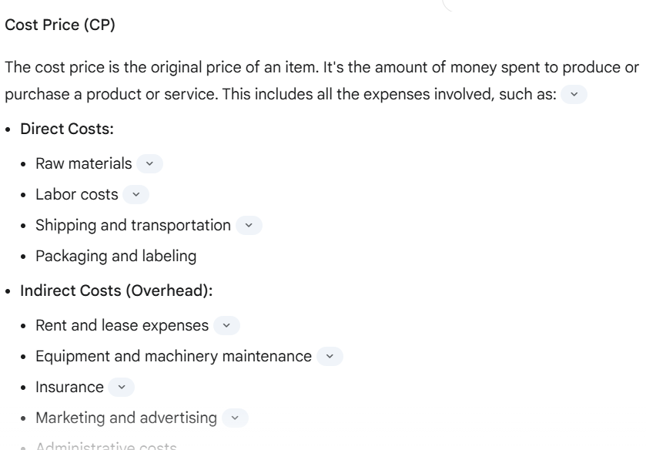

**Selling Price (SP)**

* **Definition: The selling price is the price at which a product or service is actually sold to the customer.**

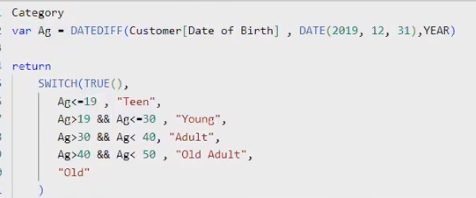

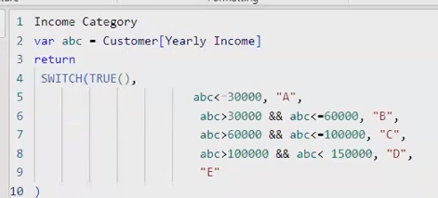



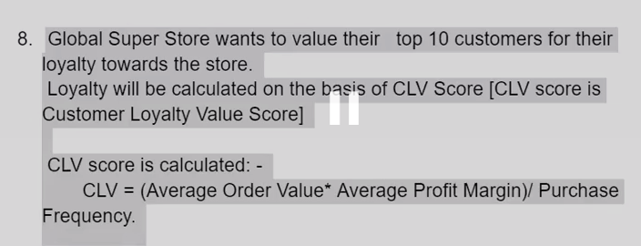

**Customer Loyalty Score (CLS)** is a metric that quantifies the strength of the relationship between a customer and a brand. It measures the likelihood of a customer to repeatedly purchase from a business and recommend it to others.

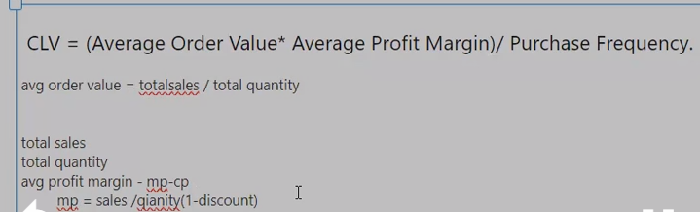

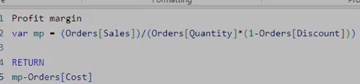

**Order id will be same when customers orders more than one order in a single time**

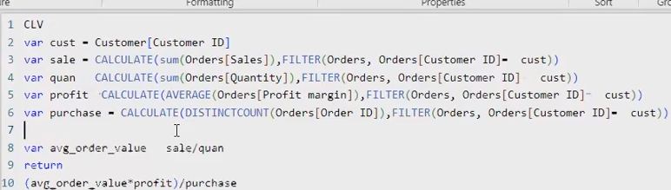

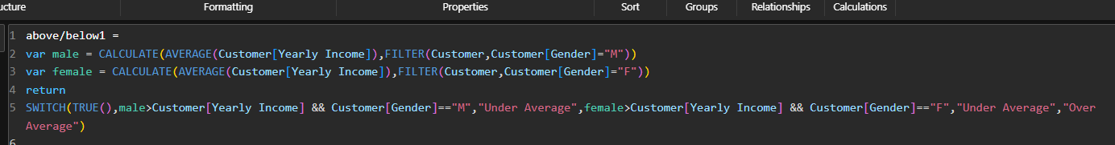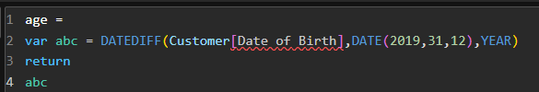

**Profit percentage=(profit/sales)*100**

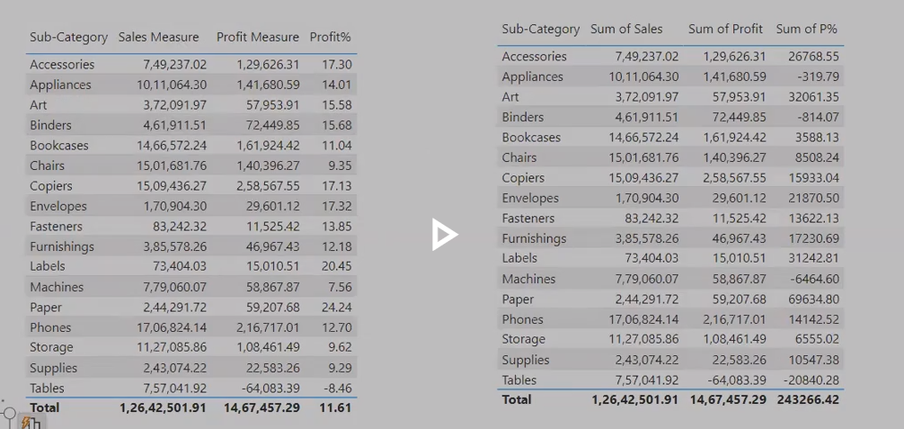





**rankx**



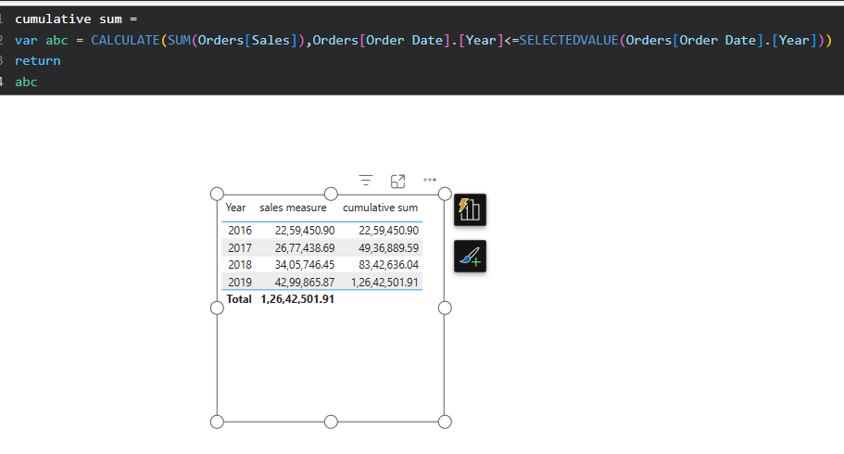

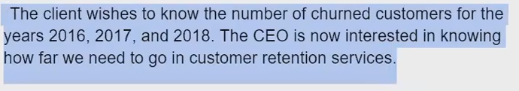



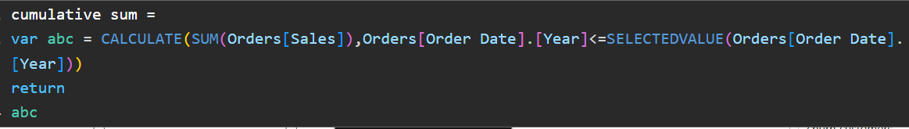

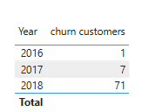



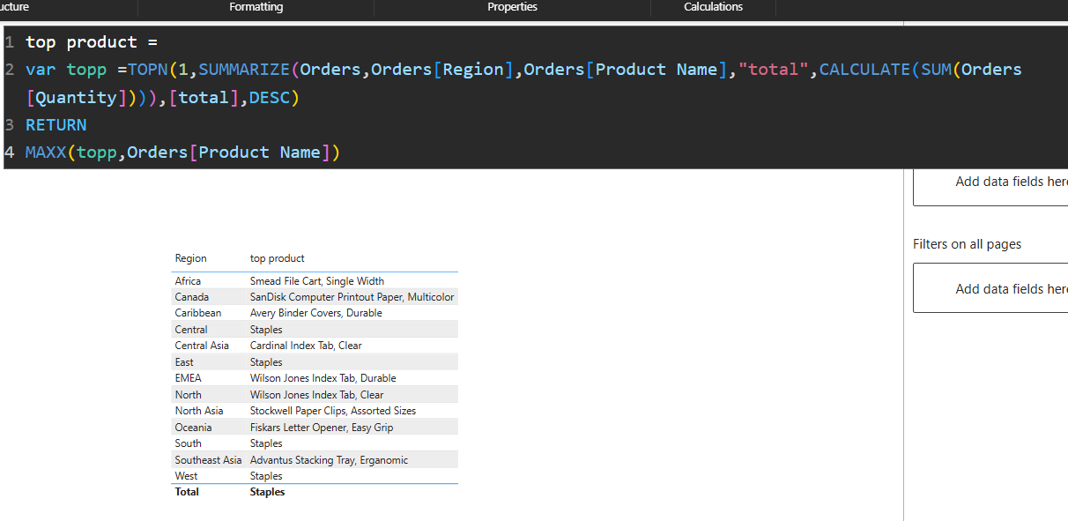

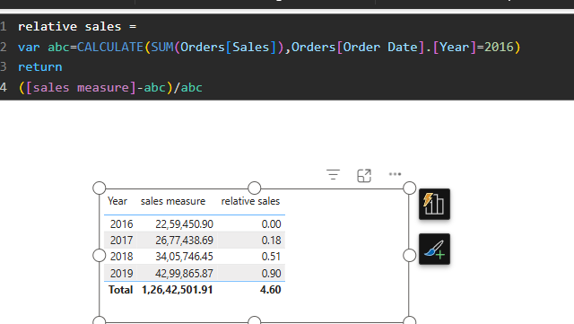

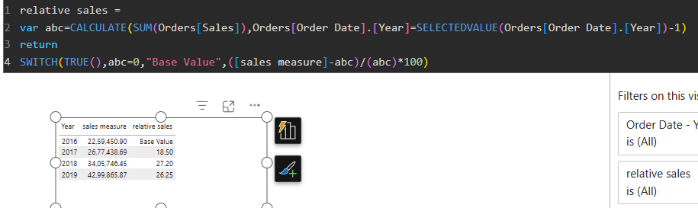

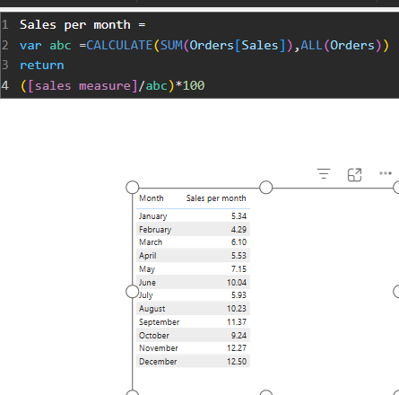

**If u don’t want your static visual to change with filter then u can use All .**

**Measures** are calculation and aggregation to build logic and solve business problems

Most use case of dax is measure

**{measures are aggregations}

**Measures** are of two types: **Implicit: Aggregations that power bi does on its own(figures and visuals in the power bi are all implicit measures)**

**Explicit: That we as a user create from our end**

**\*Always made measures in a new table (modelling🡪 new table)**

**Measures are often used to aggregate data, such as summing, averaging, or counting values.**

**Measure aggregate dynamically based on the context of the visuals**

**Measures are space saving ,when call only in action otherwise dead, and colums occupies space**

**Column and measure made from DAX**

**Columns remains permanent in the data frame and occupies the space , whereas Measures is a space saving ,it comes into action when called.**

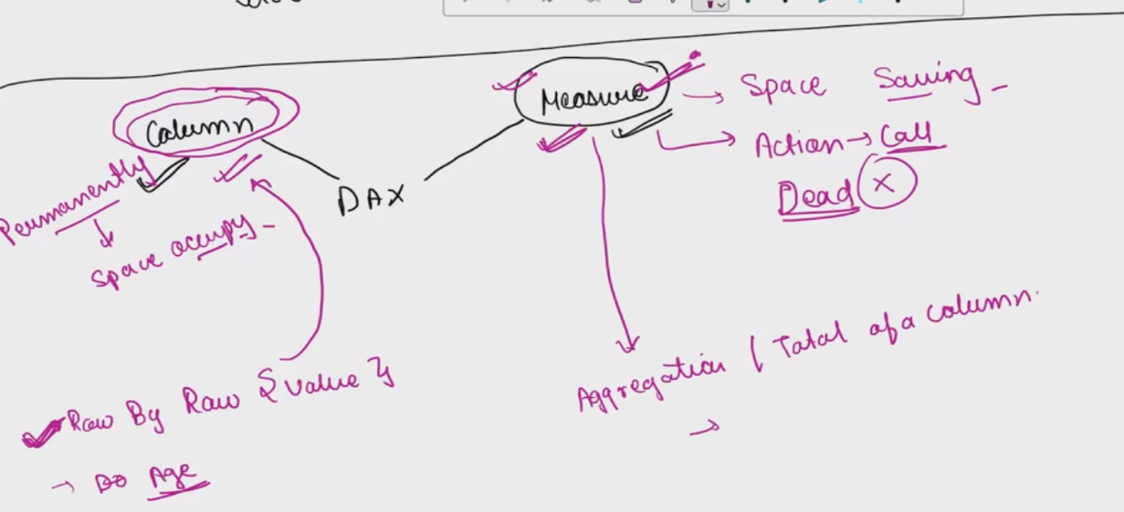

**When u want row by row value use column**

**When u want aggregations of column then use Measure**

**Filter context : data that is being displayed**

**In Power BI, filter context refers to the set of filters that are applied to your data when performing calculations**

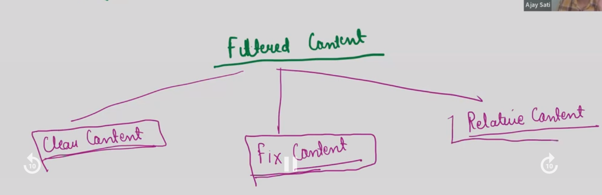

**Fix context : parameters are static**

**Give me a a sales of segment “ consumer” and year “2018”**

**2018 consumer sales = CALCULATE(SUM(Orders[Sales]),FILTER(Orders,Orders[Segment]="Consumer"),FILTER(Orders,Orders[Order Date].[Year]=2018))**

**Relative context🡪 when I judge one value relative to another value**

**Ankita ke marks , Anushka se kitne km ya Jayda hain**

**Q Increase in sales percentage for each as compare to 2016?**

**ALL – IGNORES ALL THE FILTER**

**Returns a value ignoring any filter that might have been applied**

**total sales = CALCULATE(SUM(Orders[Sales]),ALL(Orders))**

**ALL NULLIFY THE FILTRE OF THE VISUAL AND NOT INTERACT WITH THE FILTRE THAT IS OUTSIDE OF THE VISUAL**

**ALLSELECT NULLIFY THE FILTRE OF THE THE VISUAL BUT INTERACT WITH ANY FILTER THAT IS OUTSIDE OF THE VISUAL.**

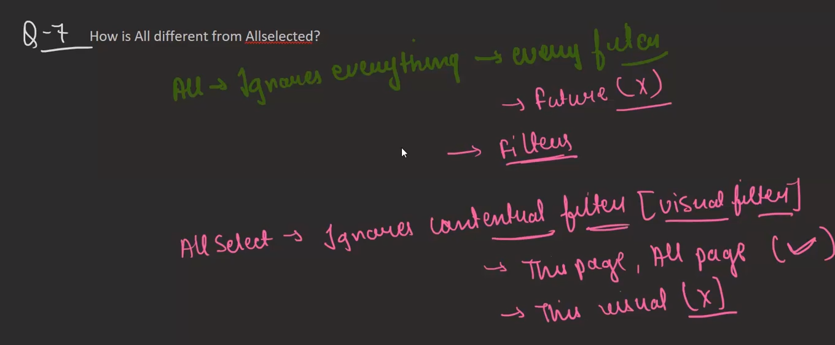

**Parametrized charts are nothing but they are slicers that are made from human**

**And power bi will create table for it**

**Waterfall Chart::🡪 Waterfall charts are a powerful visualization tool in Power BI, particularly useful for understanding the impact of positive and negative changes on a starting value.(show both positive and negative contribution)**

**Tree map : never show negative contribution,More the size ,more will be the contribution.**

**Scatter plot : To compare two numericals value we use scatter plot**

**plt.scatter(df[“cgpa”],df[“salary”])**

**Scatter plot is (by default automatic visual)**

**QUICK MEASURE: ai to make measure**

**PROBLEMS IN OUR DATA-🡪Null values, missing values, outliers ,blank,duplicates,unstructed data,mixed values, different data types**

**POWER QUERY : Data Cleaning: Remove duplicates, handle missing values, and correct inconsistencies.**

**Change in power Bi desktop will not reflect in Power query**

**No DAX used in power query**

**Power Query records the steps the performed by u in the sequence.**

**Q DOES POWER QUERY OCCUPIES SAPCE FOR THE STEPS RECORDED?**

**ANS NO ,it only occupy the space pbix file but not when it is publish/live**

**View 🡪 Advance editor to see the code of M language**

**Power Query mein table to query bolte hain**

**Query dependencies🡪query🡪view🡪 This will display a diagram showing the relationships between queries, including the flow of data from source to target.**

**• Excel workbooks**

**• CSV files**

**• Database connections (SQL Server, Oracle, etc.)**

**• Web data sources (APIs, web scraping)**

**• Other Power BI datasets**

**A bidirectional relationship in Power BI is a relationship between two tables where filters can propagate in both directions.This means that when you select a value in one table, it filters the related table, and vice versa.**

**Why Avoid Bidirectional Relationships:🡪**

**While bidirectional relationships can be useful in certain scenarios, they can significantly impact performance, especially in complex data models.**

**Use Unidirectional Relationships: Whenever possible, establish unidirectional relationships between tables. This reduces the complexity of query processing and improves performance.**

**Conditional Columns**

**A conditional column in Power BI is a new column that is created based on specific conditions applied to existing columns in your data.(use IF ELSE HERE) (and/or not used here)**

**In Conditional column we use if else conditions and don’t use logical operators(and /or)**

**Custom Columns**

**A custom column in Power BI is a new column created by applying a formula or expression to existing columns(M) code**

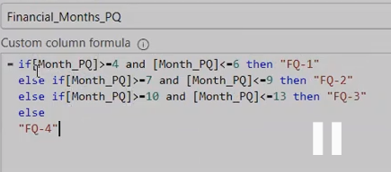

**By default power bi Sunday =0**

**Q We can make same column from power query and DAX?**

**Ans Simple Transformation 🡪 Use power query ,it will save memory**

**IF u make basic changes through dax then it runs again and again that’s decrease the performance**

**(MERGE QUERIES)Fuzzy matching in Power BI is a technique used to compare and match text values that are not an exact match. It is particularly useful when dealing with data that contains typos, variations in capitalization, or other inconsistencies.**

**The similarity threshold determines how close two values need to be to be considered a match. The default value is 0.8, meaning that two values must be at least 80% similar to be matched.**

**Merge Columns 🡪 Used to combine two columns**

**MERGE QUERIES🡪 Merge Queries joins the table sidewise .(common column between table)**

**APPEND QUERIES 🡪 For using Append queries(two join two tables) the name of the column and data types of columns must be same.Table combine(updown)**

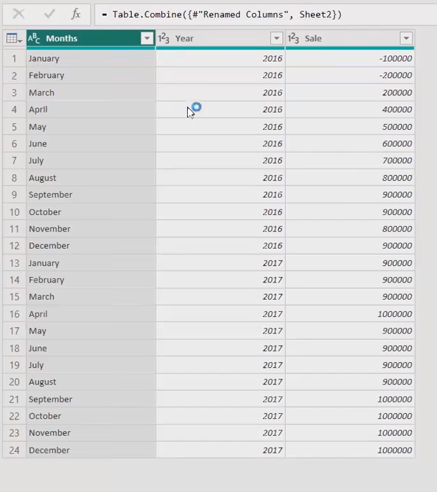

**GRANULARITY 🡪 kitni detail mein aap apne data ko show krna chate hein that is known as granularity**

**GROUPBY 🡪 It allows you to group your data based on one or more columns, enabling you to perform aggregate calculations (such as SUM, AVERAGE, COUNT, MIN, MAX) within each group.**

**Data Summarization:**

* **Condenses large datasets into smaller, more manageable summaries.**

**Yes, Power BI Service is a cloud-based business analytics service.**

**Here's a breakdown:**

* **Cloud-Based: This means it's hosted and accessed over the internet, rather than being installed on your local computer.**
* **Power BI Desktop is a local application that you install on your computer**

**In Power BI Services, a workspace is a collaborative environment where you can:**

**Facilitaes the collaborative engineering**

* **Store and manage your Power BI content: This includes reports, dashboards, datasets, dataflows, and other related assets.**
* **Collaborate with others: Workspaces facilitate teamwork by allowing you to share content with colleagues and control their access permissions.**
* **Create and publish apps: You can bundle collections of dashboards and reports into apps and distribute them to a wider audience within your organization**

**When u publish your report in power bi service then u will be see two things 🡪**

* + - * **One is your report and another one is your data mode**

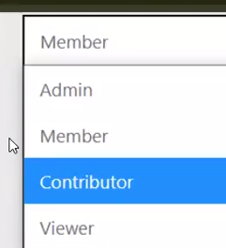

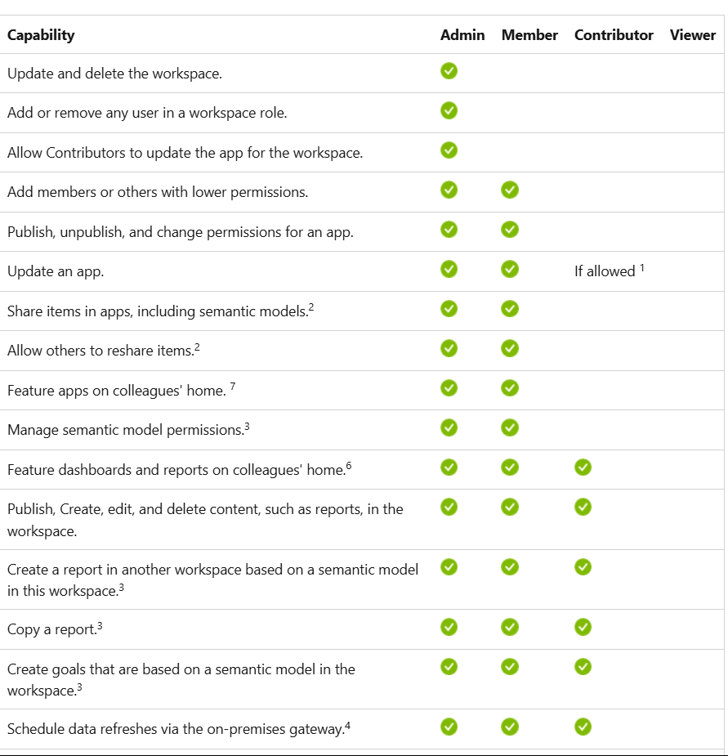

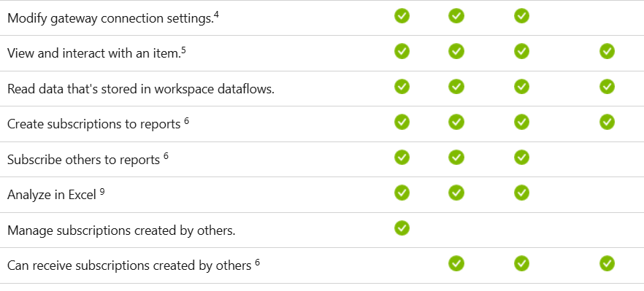

**ROW LEVEL SECURITY(RLS)🡪**

**Row-Level Security (RLS) in Power BI is a powerful data security feature that allows you to control which rows of data individual users can see within a report or dataset.**

**Modelling🡪 Manage roles**

**50% kaam (desktop) pe hota hai aur 50% kaam power bi service pe hota hai**

**Row level security 🡪 Because u control the number of rows that u display to particular user.**

**Powerbi service🡪 semantic🡪 security**

**If u control the data modelling the visuals control automatically**

**RLS ONLY APPLY TO VIEWERS (MANAGE ACCESS)**

**PUBLISHING MEANS NOW YOUR REPORT IS NOT PRESENT IN LOCAL SYSTEM ,IT IS PRESENT IN YOUR CLOUD**

**WORKSPACE🡪MANAGE ACCESS**

**IF YOUR REPORT HAS RLS THEN U CANT SHARE IT PUBILCLY BUT IF U DON’T HAVE RLS THEN U CAN SHARE IT PUBLCLY**

**U can see the report without login, only if there is no ROW LEVEL SECURITY in your report.**

**And if there is a row level security in your report then u have to login to view the report**

**SELF SERVICE BI🡪 new🡪Report**

**Self-service BI empowers business users to independently analyze data and generate insights without relying on IT or data analysts. It provides tools and platforms that enable users to:**

* **Access data: Connect to various data sources, including databases, spreadsheets, and cloud applications.**
* **Prepare data: Clean, transform, and prepare data for analysis.**
* **Analyze data: Use drag-and-drop interfaces, visualizations, and natural language queries to explore data.**
* **Create reports and dashboards: Build interactive reports and dashboards to share insights with others.**

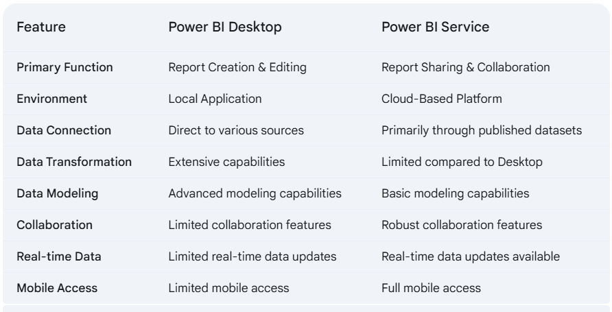

**Power BI Desktop**

* **Local Application: Installed on your computer.**
* **Report Creation: Primarily used for designing and creating reports and dashboards.**
* **Data Connection: Connects to various data sources, including databases, spreadsheets, and cloud applications.**
* **Data Transformation: Enables data cleaning, shaping, and transformation using Power Query.**
* **Data Modeling: Creates data models to define relationships between tables and optimize data analysis.**
* **Visualization: Creates interactive visualizations like charts, graphs, and maps.**
* **Offline Access: Allows for report creation and editing offline.**

**Power BI Service**

* **Cloud-Based Platform: Accessed through a web browser.**
* **Report Sharing and Collaboration: Primarily used for sharing reports, dashboards, and datasets with others.**
* **Real-time Data Updates: Provides real-time data refreshes and updates.**
* **Data Distribution: Distributes reports and dashboards to a wider audience.**
* **Interactive Dashboards: Enables interactive exploration of data with filters, slicers, and drill-down capabilities.**
* **Mobile Access: Allows for viewing reports and dashboards on mobile devices.**
* **Collaboration Features: Facilitates collaboration and sharing within teams and organizations.**

**in self service bi we can only work with measures and reports that are made on power bi desktop**

**Q What is the difference between power bi desktop reports and power bi service reports?**

**Ans In Power BI desktop reports we make visuals,new columns,datamodelling ,measures**

**On the other hand power bi service reports u can make visuals based on the data model that is already created**

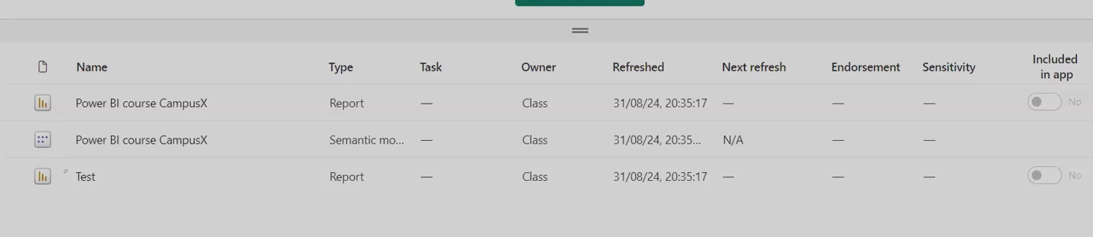

**Combine these two reports 🡪 Power BI give another feature called Dashboard**

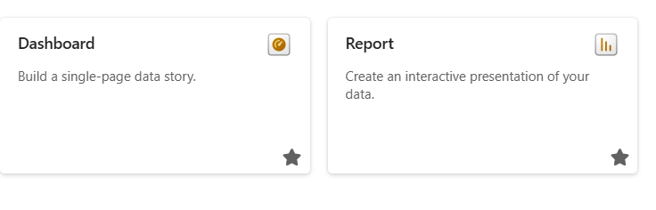

**DAshboard in power bi is a hyperlink to different different report pages.**

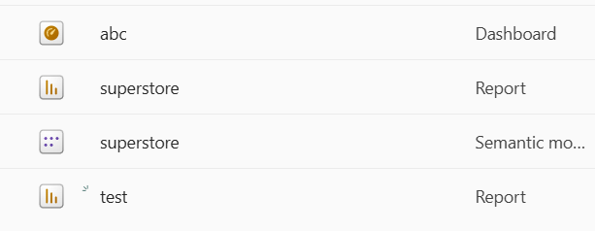

**Power BI Reports🡪 In-depth data analysis and exploration,DesignMulti-page, complex layouts, detailed visualizations.**

**Power Bi Dashboards🡪 High-level overview and monitoring,Single-page, concise layout, key performance indicators (KPIs).**

**While Power BI dashboards can incorporate elements that link to other reports, they are not solely collections of hyperlinks. Here's a more comprehensive** explanation:

BASIC CHANGES U CAN DO IN DASHBOARD (TITLE CHANGE,THEME CHANGE)

Power BI Da**shboards:**

* **Centralized Hub: Dashboards serve as a central hub for visualizing key performance indicators (KPIs) and insights derived from your data**

**General Guidelines:**

* **CEOs: Dashboards can provide CEOs with a quick, high-level overview of key performance indicators (KPIs), trends, and the overall health of the business.**
* **Managers: Reports can provide managers with more detailed information for specific areas of responsibility, allowing them to analyze performance, identify trends, and make informed decisions.**

**\*\*\*DASHBOARDS ARE NOT INTERACTIVE, WHENVER U CLICK ON THE DASHBOARD VISUAL ,IT WILL REDIRECT US TO THE REPORT PAGE**

**\*\*\* in dashboard we cant create any charts/visuals**

**\*\*\* DASHBOARD 🡪 PIN ONLY GRAPHS AND VISUALS ,AND NOT SLICERS**

* + - * **REPORTS ARE INTERACTIVE**
      * **In REPPORTS WE CAN CRETAE CHARTS AND VISUALS ON THE BASIS OF DATA MODELLING**
      * **IN REPORTS 🡪 SLICERS,VISUALS,CHARTS ARE ALL ARE THE PART OF REPORTS**

**POWER BI ARCHITECHTURE 🡪**

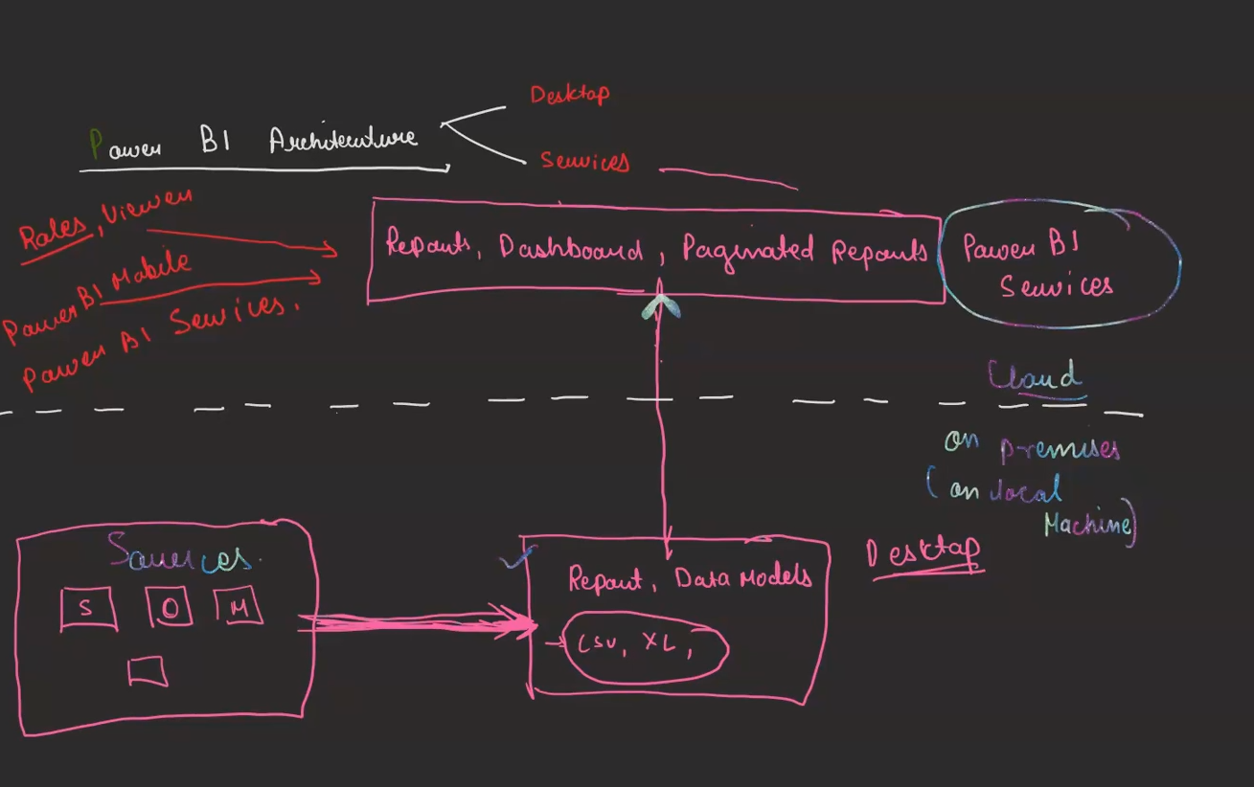

**Data Flow:**

1. **Data Ingestion: Data is extracted from various sources, both on-premises and cloud-based.**
2. **Data Transformation: In Power BI Desktop, data is cleaned, transformed, and modeled using Power Query.**
3. **Report Creation: Reports and dashboards are created in Power BI Desktop using visualizations and interactive elements.**
4. **Publishing: Reports and dashboards are published to the Power BI Service.**
5. **Data Refresh: Scheduled data refreshes keep reports and dashboards up-to-date with the latest data.**
6. **User Interaction: Users interact with reports and dashboards in the Power BI Service, exploring data and gaining insights.**

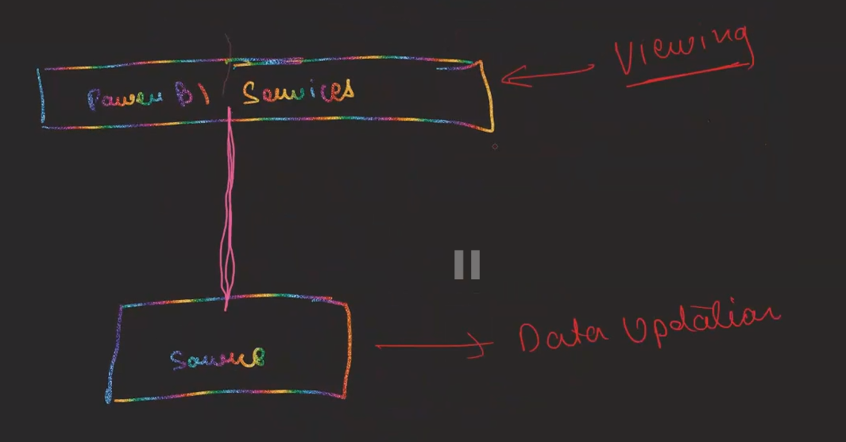

**When we say "firewall on a data source," we're essentially talking about the security measures in place to protect the data source itself from unauthorized access.**

**To breach the fireball,we need a GATEWAY**

**Keep your dashboards and reports up to date by connecting to your on-premises data sources without the need to move the data.**

**Semantic model🡪 settings**

**Refresh**

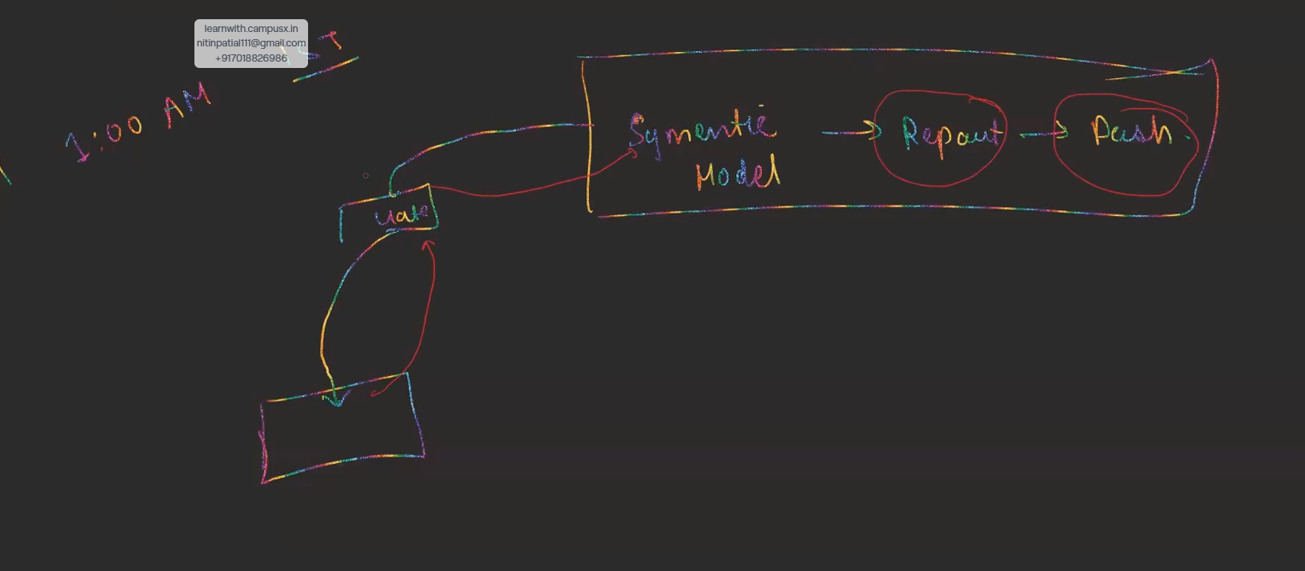

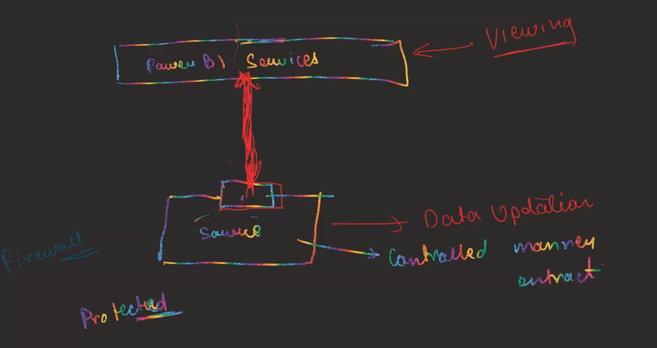

**Controlled manner data extract**

**GATEWAY🡪 after publishing the report in service u have to updated with the data,since the sql server and excel we have used in our report that is present in our local system that is called (on premises) ,so in order to refresh our report in our power bi service(on cloud) ,there should be a link between our cloud and local system,so this GATEWAYS acts as a bridge through which we can transfer our data from local system to cloud.**

**Here's what it does:**

* **Connects On-premises Data: Enables you to connect to data sources located within your organization's network, such as databases (SQL Server, Oracle), files (Excel, CSV), and other on-premises systems.**
* **Secure Data Transfer: Facilitates secure and reliable data transfer between your on-premises environment and the Power BI Service, ensuring that data is protected during transit.**

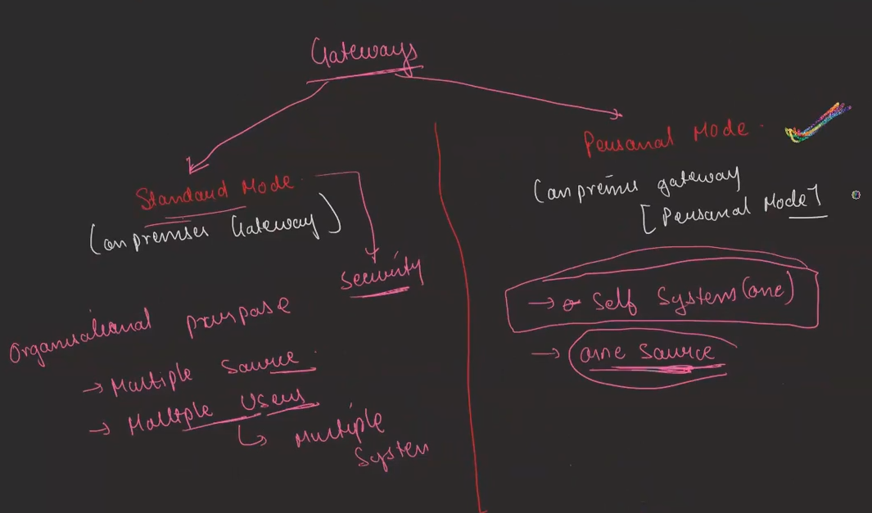

**TO USE THE POWER BI SERVICE WE MUST HAVE A LICENSE TO USE IT 🡪**

**Free Licensce(60 days)**

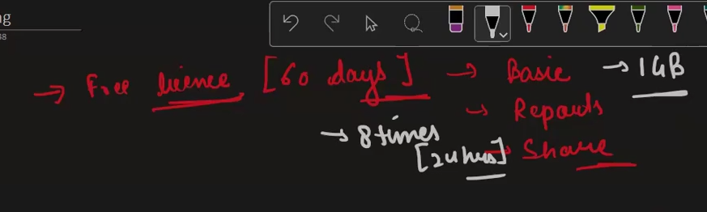

**PRO license**

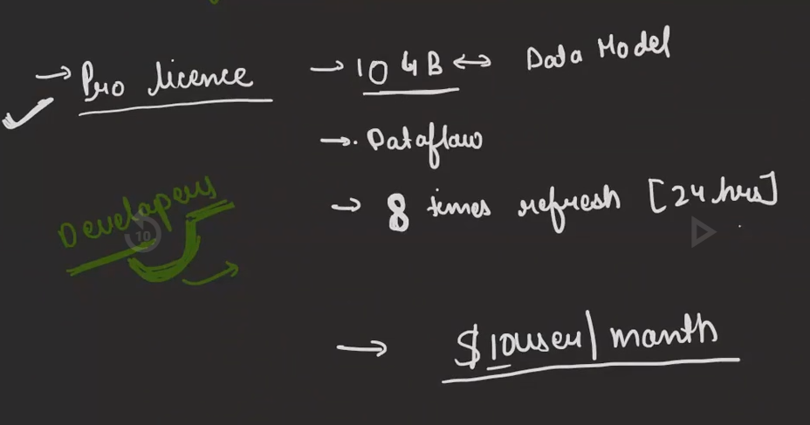

**Premium License🡪**

**1.Premium Per user (PPU)**

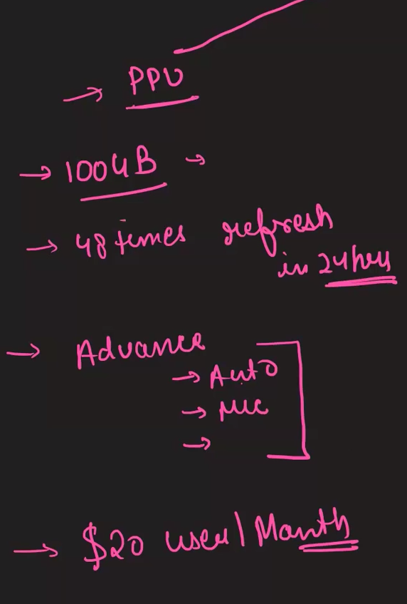

* 1. **Premium Per CApacaity(PPC)**

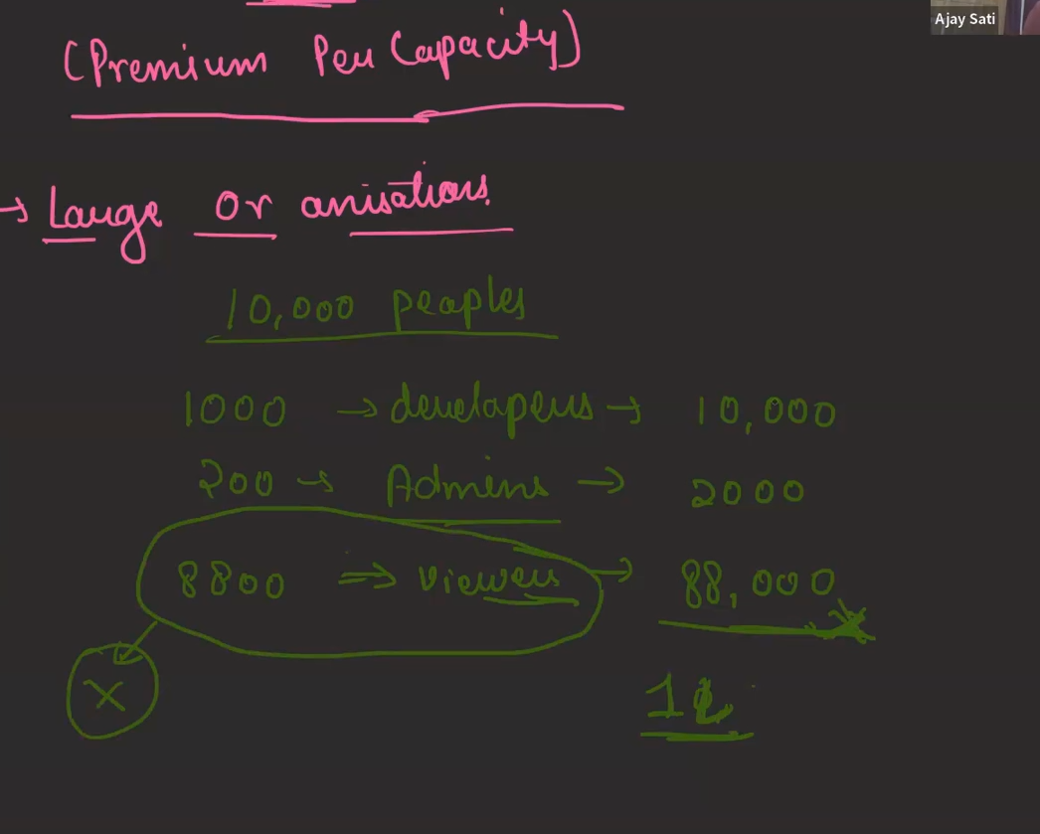

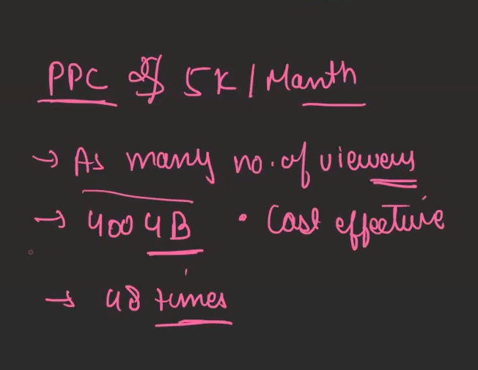

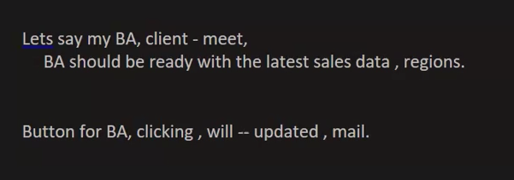

**POWER AUTOMATE🡪Power Automate transforms Power BI from a static reporting tool into a dynamic and interactive platform**

**Automated Data Refresh: Schedule regular updates to your datasets, ensuring your reports always reflect the latest information.**

**Integration with Other Services: Connect Power BI with other services like Microsoft Teams, Outlook, SharePoint, and more.**

**Actionable Insights and Automation:**

* **Triggering Actions Based on Data: Power Automate can be used to trigger actions based on specific data conditions within your Power BI reports. For example, you could trigger a notification to be sent when a key metric exceeds a certain threshold.**

**Report Distribution and Sharing:**

* **Automated Report Delivery: Power Automate can be used to schedule and automate the delivery of reports to specific recipients via email or other channels. This ensures that stakeholders receive timely insights and updates.**

**PAGINATED REPORTS ARE GENERALLY FOR PRINTING PURPOSES**

**Deployment Pipelines🡪 create workspace🡪advance🡪enable premium per user**

**DEVELOPMENT 🡪 TESTING🡪 PRODUCTION**

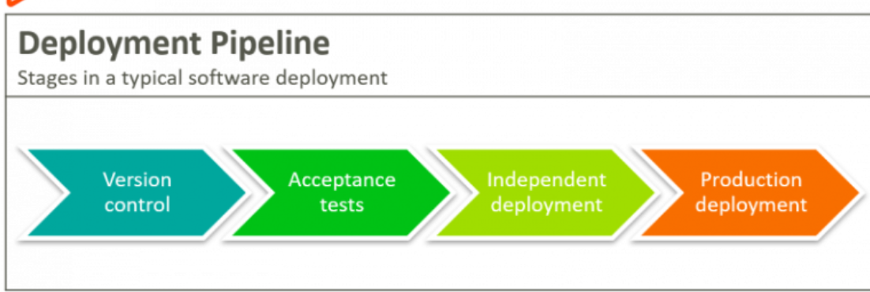

**A deployment pipeline is a set of automated processes and tools that facilitate the continuous integration and continuous delivery (CI/CD) of software applications. It helps developers and teams to automate the steps required to build, test, and deploy code changes to production environments. The primary goal of a deployment pipeline is to ensure that software can be reliably and efficiently delivered to users.**

**IT PROVIDES THE DEDICATED ENVIRONMENT OF DEVELOPMENT,TEST AND PRODUCTION**

**Track the changes between the development test and production**

**It will automate our process,if u are not using deployment pipelines it will be time taking,and u will manually created the three different workspaces and manage the reports withing these workspaces manually**

**3 workspace develop automaticaaly**

**1.Development 🡪 CLICK DEPLOY (ALL THE REPORTS AND SEMANTIC MODALS WILL DEPLOY ON THE TESTING PHASE)**

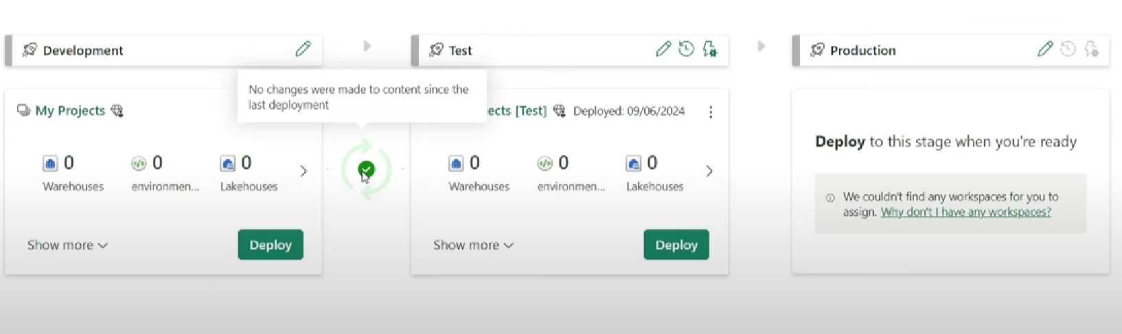

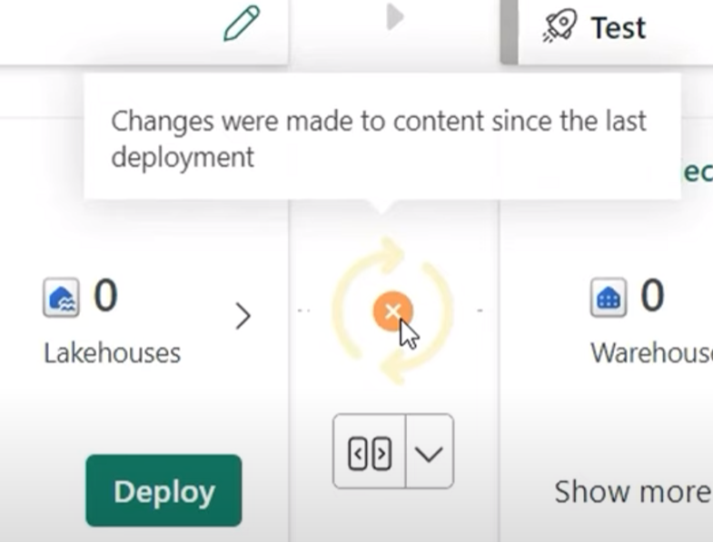



**Not equal to 1 means 🡪 1 content not matching between two workspace**

**2. Testing**

**3.Production *share with a end user**

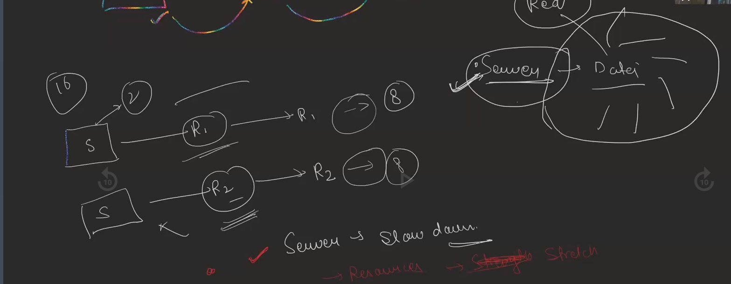

**Server is the central repository,many depaartments are working on it**

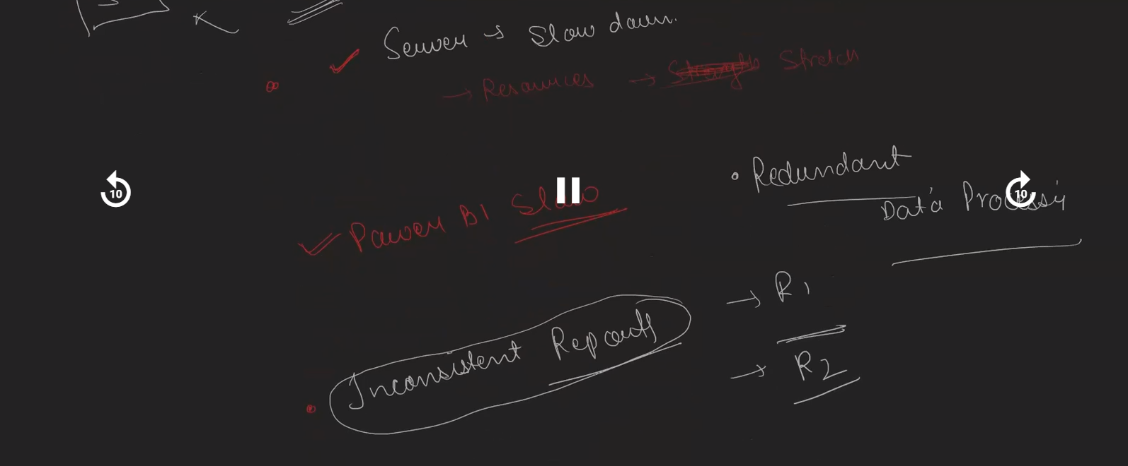

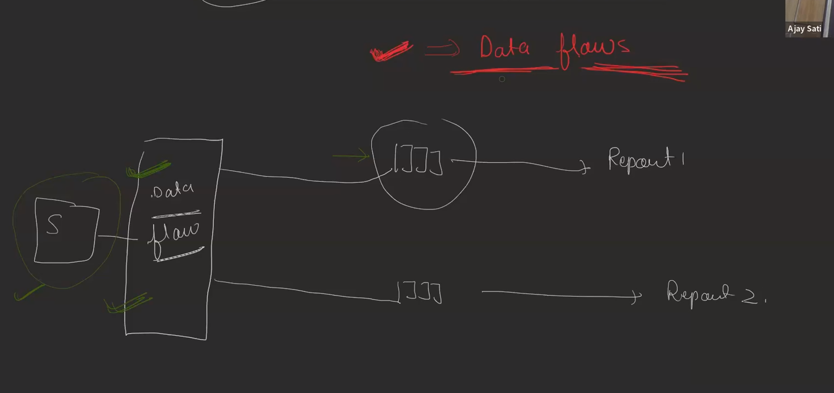

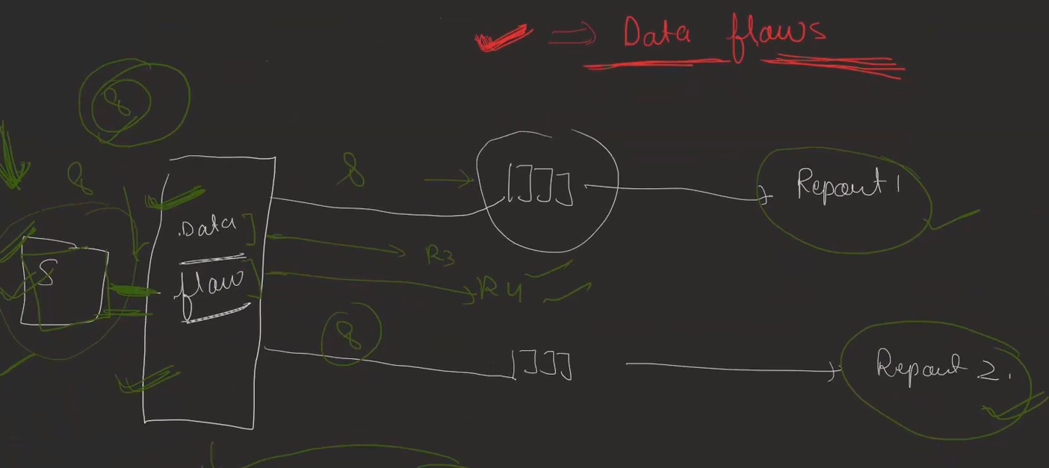

**SERVER SE DATA🡪 DATA FLOW(STORE IN CACHE MEMORY)(RAM)**

**(Bringing data from cahce memory to report is very fast)**

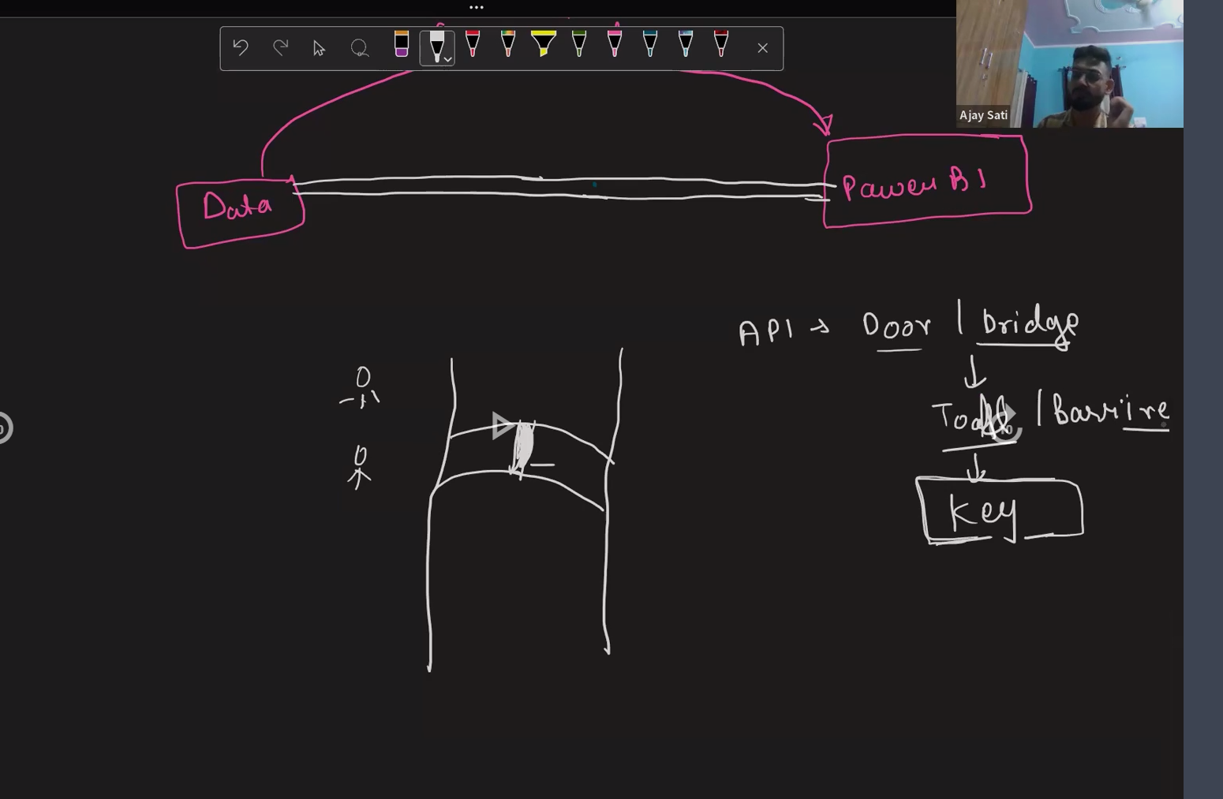

**GOOGLE CLOUD PLATFORM(GCP),OUTLLOOK,GOOGLE DRIVE,POWER AUTOMATE,API,PYTHON**

**APIs (Application Programming Interfaces) are essential for modern software development and integration. Here's why we use them:**

* **Data Sharing and Integration:**
  + **Connect Different Systems: APIs allow different software applications to communicate and exchange data, even if they were built on different platforms or by different companies. This enables seamless integration between various systems within an organization or across different organizations.**
  + **Service account 🡪 when u have to connect between two different servers**
  + **One is DRIVE AND ANOTHER ONE IS POPWER BI**

**f you create a column using DAX instead of Power Query in Power BI, here's what might happen:**

**Potential Impact on Performance:**

* **Slower Data Refresh: DAX calculations are performed in memory within Power BI after the data is loaded. This can lead to slower refresh times, especially with large datasets or complex calculations.**
* **Increased Memory Usage: DAX calculations can consume more memory than Power Query transformations, particularly with complex formulas or large datasets.**

**Flexibility and Control:**

* **Greater Flexibility: DAX offers more flexibility and control for complex calculations, including time intelligence functions, lookups across tables, and conditional logic.**
* **Easier for Complex Logic: If your column requires complex logic or calculations that are difficult to achieve in Power Query, DAX might be a better option.**